Name: Ashwin Yadav

Enrollment No: 232026900131

Subject: Frontend Development  
Date: 24-03-2025

Exam Type: Assignment

Q1: Make a adynamic color palette (When user will click on color Text should be change with selected color as well as the background color)  
  
Ans 1: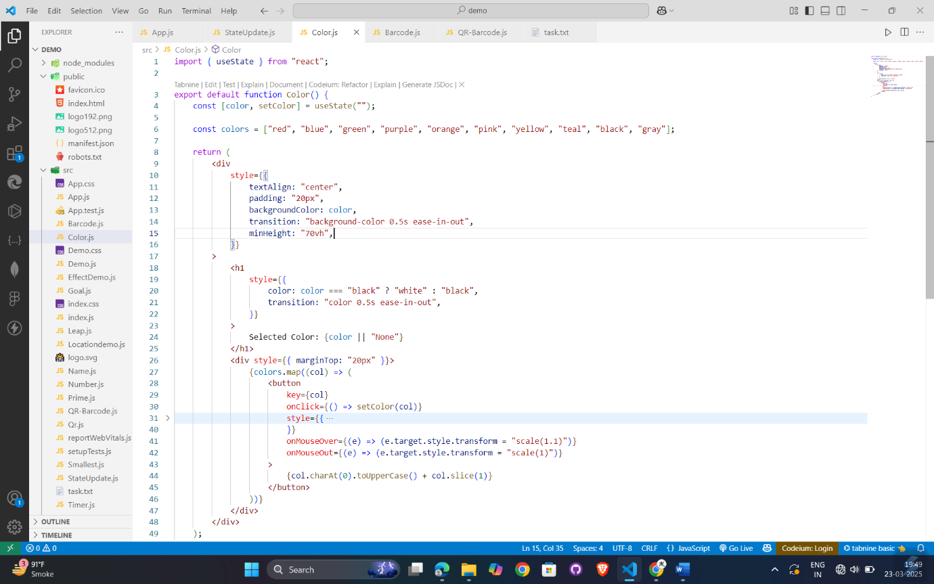

Output 1:

